**WB**

1>Add to sample-  Sample quantity not showing   
2>Bill not downloading in m.s.word(only invoice )  
3>Stock panel not showing in the same page of the invoice(also done in both bihar odisha)  
4>Sales and stock statement-  All - option should be there(also done in both bihar odisha)  
5>Reports and stock invoice - Products , stockists name, MR name should come Alphabetically(Changes are done in opening balance,opening stock,Invoice,Replacement Invoice,Cr note Invoice, Purchase, sales stock register,Party wise,MR wise,Bihar depo generate ,Odisha depo generate => IN WB BIHAR AND ODISHA also)  
6>All reports should be saved/download in M.s. Word (Free PDF will not work on your software as it has a S/5 login pannel which is conflicting with free pdf .If you need pdf badly You need to buy PDF API )  
7>In case of bills- Decimal should be taken by two digits

**Bihar/Orissa**  
  
1>No print option in Transfer Status  
2>Incase of Food product, the tax is getting calculated in as 5% instead of 13.5% in Bihar and orissa. (Sir It is already ok please check it once with new item)  
3>In case of bills- Decimal should be taken by two digits.  
  
4>Incase of customerwise/productwise sales report- Customer name should come in a collumn  
5>Sample option not there(As per we have discused earlier there is no effect of sample in software for any of two states except West Bengal . Wb can generate Sampel only.)  
6>Opening balance, not coming in the ledger

Procedure For Making Word

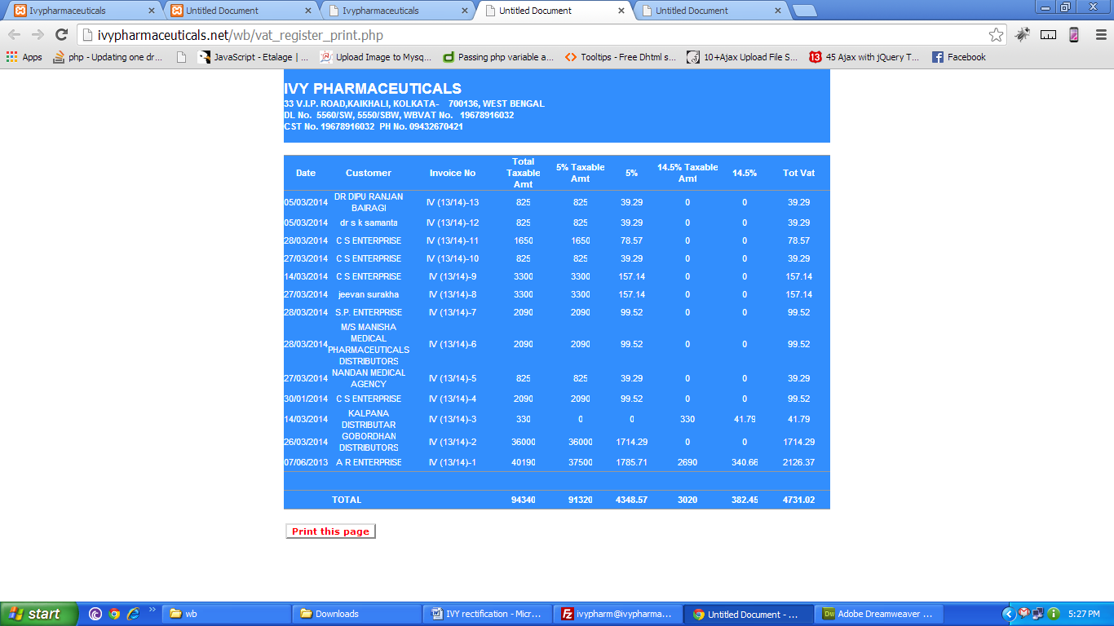

Select the whole page copy and paste in word

Bill- Decimals are done in this pages for all the three States

Invoice bill

Replacement invoice bill

View invoice details

View reinvoice details

Credit note bill

Crnote details

sales register print

vat register print

party wise print

party product wise print

mr wise print

mr product wise print

credit note register print

bihar depo bill

odisha depo bill

bihar depo detail

odisha depo detail